1. Write a C program to check whether a number is multiple of 2 or 3 or 5. If

it is then print “This number is multiple of 2”, “This number is multiple of

3” and “This number is multiple of 5”, number can be multiple of all 3

numbers given, if the number is not multiple of given numbers, the

program should print “This number is not multiple of 2,3,5”.

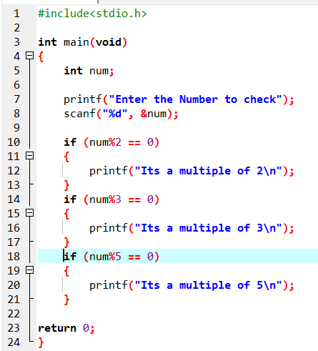

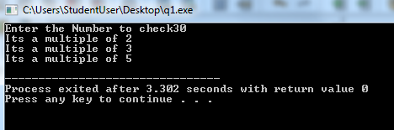

2. In Pakistan, the voter can only cast the vote if he/she is 18 years old or

greater. Construct a program that checks if the voter is eligible to cast the

vote according to his/ her year of birth. Otherwise, the program should

print “You are underage”.

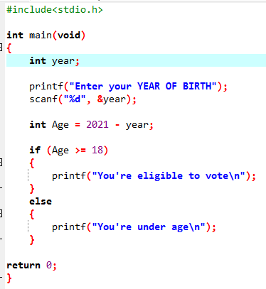

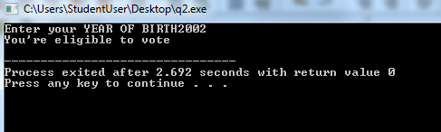

3. Construct a C Program that takes temperature as input. The temperature

should be in centigrade. If the temperature is less than zero, then the

program should print “It is a Freezing Temperature”. If the temperature is

between 0 and 10, the program should print “It is very Cold weather”. If

the temperature is between 10 and 20, the program should print “It is Cold

weather”. If the temperature is between 20 and 30, the program should

print “It is Normal Temperature”. If the temperature is between 30 and 40,

the program should print “It is Hot weather”. If the temperature is greater

than or equal to 40, the program should print “It is very Hot weather”.

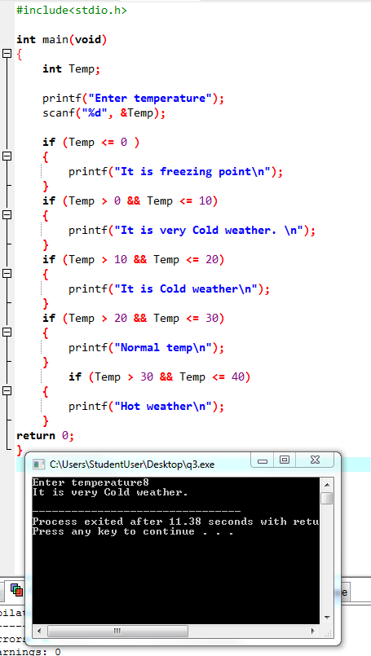

4. You must have seen the question before closing file and before saving it

“Are you sure to Save [S/s] / [N/n]? Create a program that asks for this

question if user enters S or s, it prints “Saved successfully” if the user

enters N or n it prints “Not Saved” otherwise it prints choose the right

option.

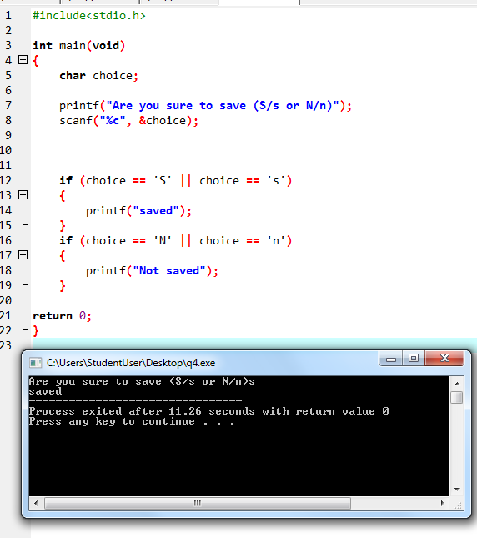

5. Create a calculator asking for operator (+ or – or * or /) and operands and

perform calculation according to the user input.

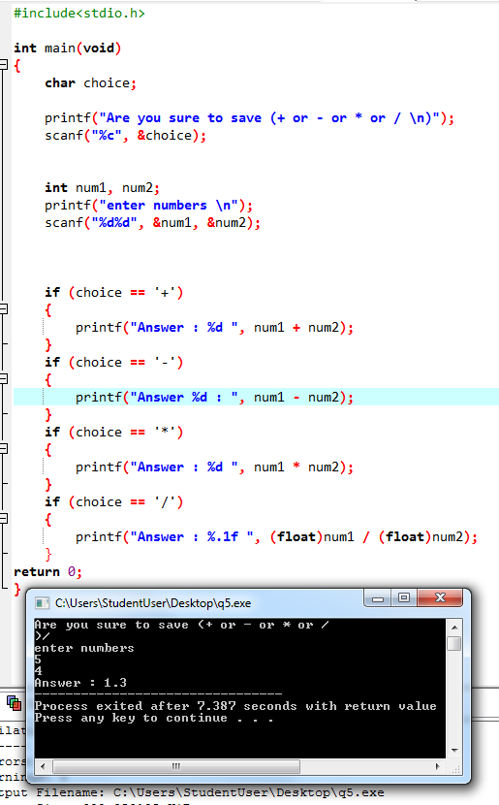

6. Construct a C Program that ask the user to give a character as input and

identify of the given character is alphabet in lowercase or alphabet in

uppercase or it is a digit or it is a special character (@,!, etc. )

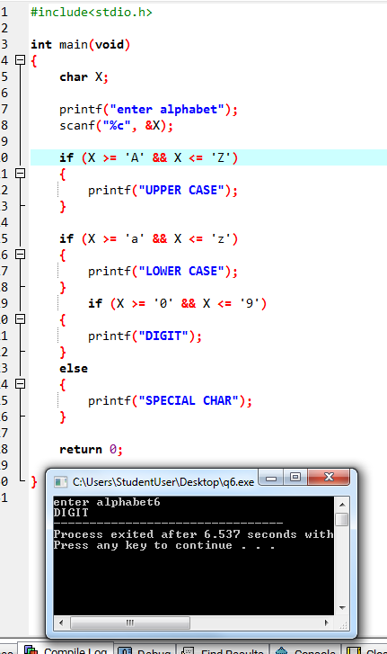

7. Write a program to check if character is vowel or consonant.

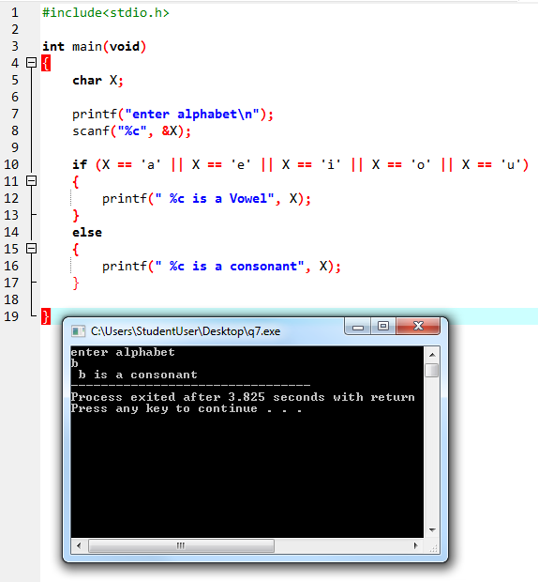

8. An equilateral triangle is a triangle in which all three sides are equal.

Isosceles triangle: An isosceles triangle is a triangle that has two sides of

equal length. Scalene triangle is a triangle that has three unequal sides.

Create a C Program that takes the values of three sides of triangle and

identify if the triangle is Equilateral, Isosceles or Scalene.

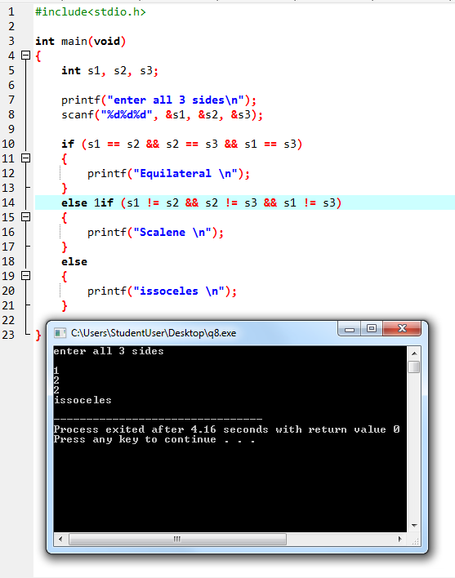

9. All the months in calendar do not have same number of days, create a

Program that takes month number as input and print the number of days

in this month. If the month has 30 days, the program should print “This

month contains 30 days”, If the month has 31 days, then the program

should print “This month has 31 days” and if the month has 28 or 29 days,

the program should print “The program can have 28 or 29 days”.

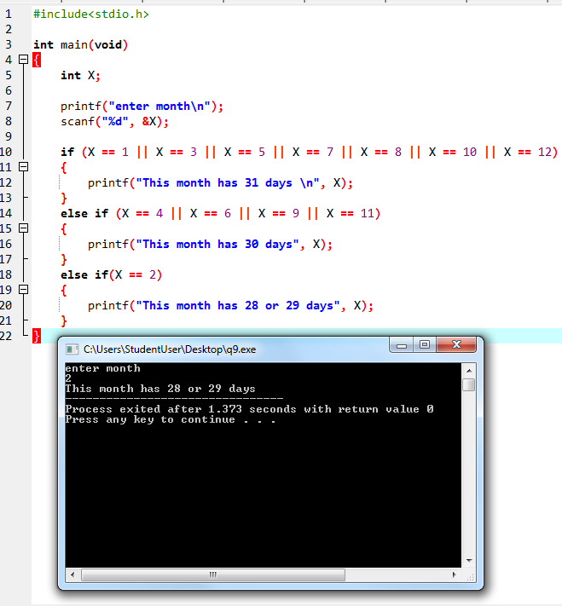

10.Write a C program to find all roots of a quadratic equation, it is required

to take user input for a, b and c values. Find discriminant using formula

discriminat = (b × b) − (4 × a × c). Compute roots based on the nature of discriminant. If discriminant > 0 then, root1 = (-b + sqrt(discriminant)) / (2*a) and root2 = (-b - sqrt(discriminant)) / (2*a).

If discriminant == 0 then, root1 = root2 = -b / (2*a). Else if discriminant < 0 then, there are two distinct complex roots where root1 =root2= -b / (2*a) and imaginary = sqrt(-discriminant) / (2 * a).

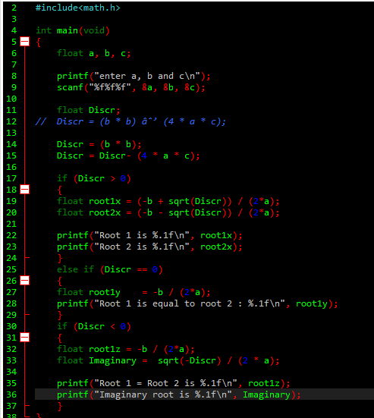

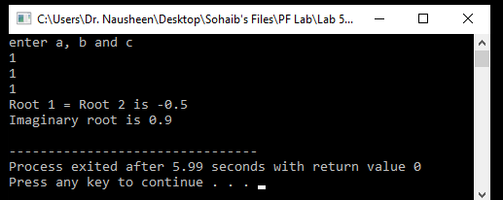

***LAB 4, SECOND PART***

3. Explain the order of evaluation of the operators in each of the following statements,

show the value of x after each statement is executed using the C program. Compare

your computed answer with the answer shown after execution of C program.

a= 2, b=4, c=2

a) a + b / c + b % 2 * a - c

b) a++*(a/b*c)+b--

c) a++*(a/b*c)+--b

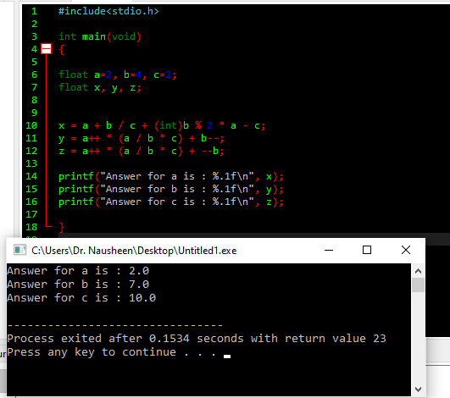

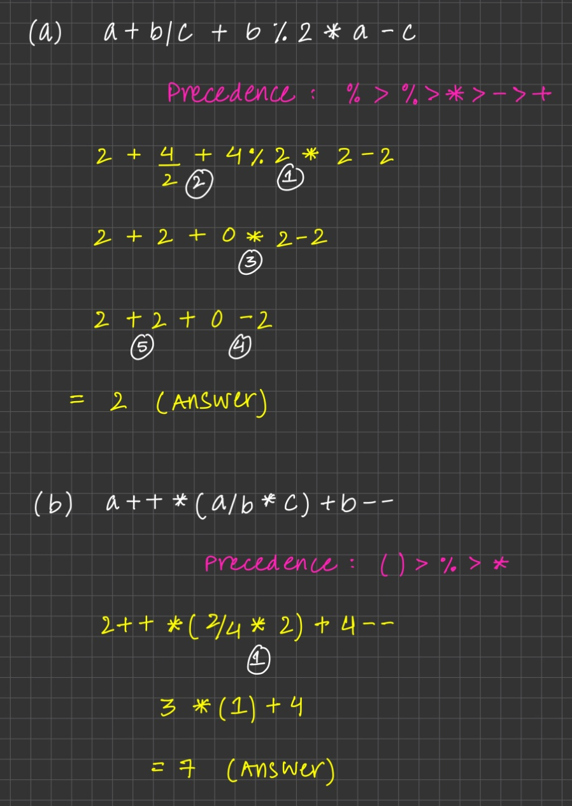

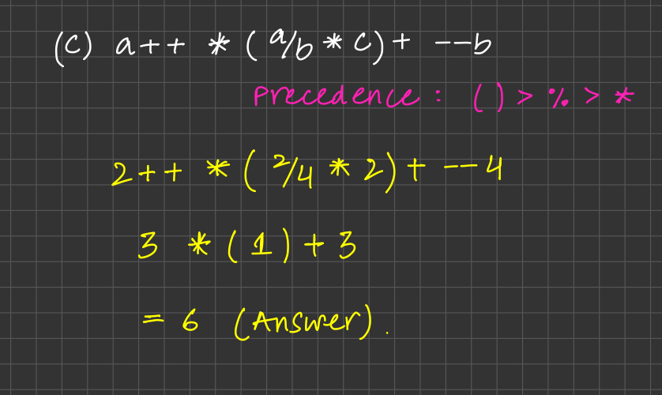

7. Write c program that find the result of the following operations: you are allowed to

initialize any values. Observe and write in comment how that operation produces

results.

● True OR False AND NOT True

● “A” > “H”

